**Lesser and Greater Outliers**

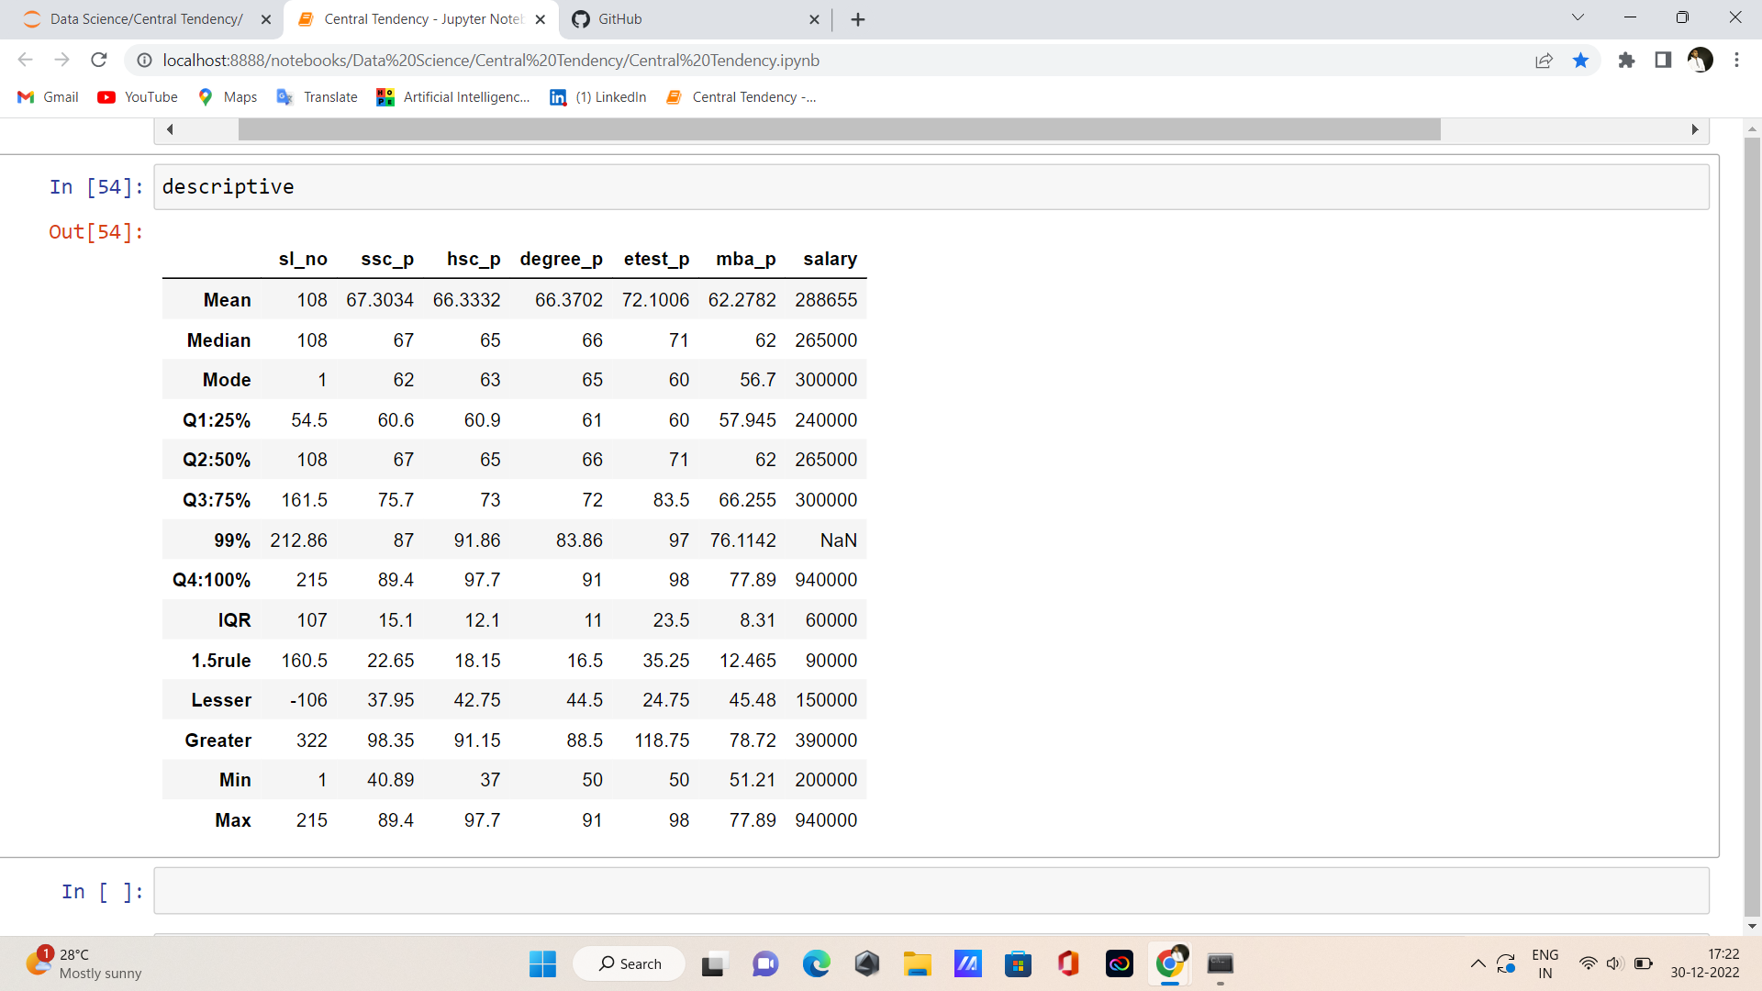

**SSC_P:**

* Lesser outlier is **not present**.
* Greater outlier is **not present.**

**HSC_P:**

* Lesser outlier is **Present.**
* Greater outlier is **present.**

**DEGREE_P:**

* Lesser outlier is **not present.**
* Greater outlier is **present.**

**ETEST_P:**

* Lesser outlier is **not present.**
* Greater outlier is **not present.**

**MBA_P:**

* Lesser outlier is **not present**.
* Greater outlier **is not present.**

**SALARY :**

* Lesser outlier is **not present.**
* Greater outlier is **present.**

**Thank you…..**